Install the python module pyinstaller. I am using 3.4 that I installed using pip (conda has one an I will try it in the future). Well, 3.4 is what I seem to have using list but when I run it, it tells me I have 4.2

Pip install pyinstaller==3.4

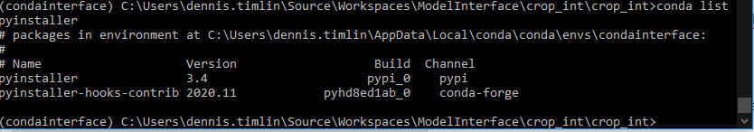

Get the crop_int.rc, crop_int.spec and pyinstall2.bat files from TF and make sure they are mapped to your crop_int folder with the source code. They should be mapped that way by default.

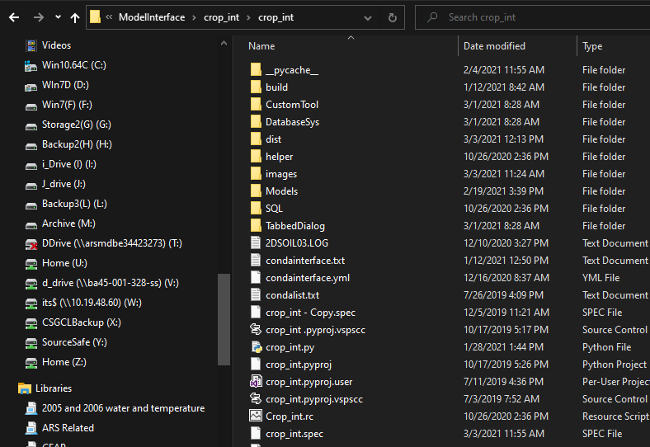

Open a command window in your environment and navigate to the folder with the source code



Run the program pyinstall2.bat from the command line. It will make two folders, build and dist.

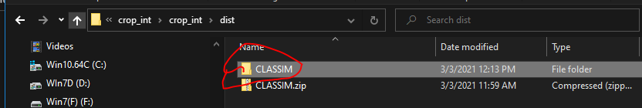

The classim folder in the dist subfolder has all the files you need to create a distribution